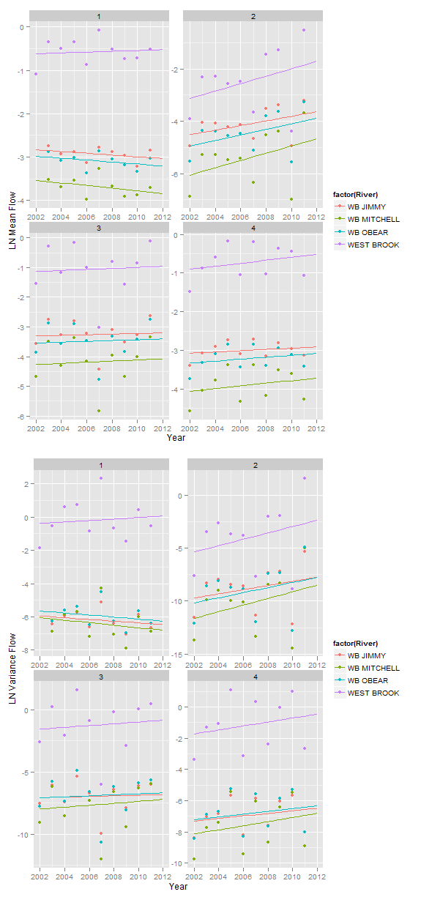

|  |  |  |  |  |  |
| --- | --- | --- | --- | --- | --- |
| Table A. Omnibus F-tests of the change in mean temperature over the study period in each season. | | | | | |
| **Season** | **Effect** | **Num DF** | **Den DF** | **F Value** | **Pr > F** |
| Spring | *Year* | *1* | *30* | *5.35* | *0.0278* |
| River | 3 | 30 | 0.67 | 0.5781 |
| River x Year | 3 | 30 | 0.55 | 0.6526 |
| Summer | Year | 1 | 32 | 2.43 | 0.1286 |
| River | 3 | 32 | 0.12 | 0.9479 |
| River x Year | 3 | 32 | 0.72 | 0.5447 |
| Fall | *Year* | *1* | *30* | *12.16* | *0.0015* |
| River | 3 | 30 | 0.31 | 0.8164 |
| River x Year | 3 | 30 | 0.22 | 0.8834 |
| Winter | *Year* | *1* | *31* | *6.85* | *0.0136* |
| River | 3 | 31 | 0.49 | 0.6931 |
| River x Year | 3 | 31 | 0.27 | 0.8459 |

|  |  |  |  |  |  |
| --- | --- | --- | --- | --- | --- |
| Table B. Omnibus F-tests of the change in mean discharge over the study period in each season. | | | | | |
| **Season** | **Effect** | **Num DF** | **Den DF** | **F Value** | **Pr > F** |
| Spring | *Year* | *1* | *33* | *13.36* | *0.0009* |
| *River* | *3* | *33* | *24.3* | *<.0001* |
| River x Year | 3 | 33 | 0.11 | 0.9524 |
| Summer | *Year* | *1* | *32* | *5.27* | *0.0284* |
| *River* | *3* | *32* | *3.42* | *0.0289* |
| River x Year | 3 | 32 | 0.08 | 0.9718 |
| Fall | *Year* | 1 | 32 | 0.14 | 0.7147 |
| *River* | *3* | *32* | *6.88* | *0.001* |
| River x Year | 3 | 32 | 0 | 0.9998 |
| Winter | *Year* | 1 | 32 | 2.04 | 0.1633 |
| *River* | *3* | *32* | *28.34* | *<.0001* |
| River x Year | 3 | 32 | 0.08 | 0.9696 |
| Flow is natural-log transformed. | | | | | |

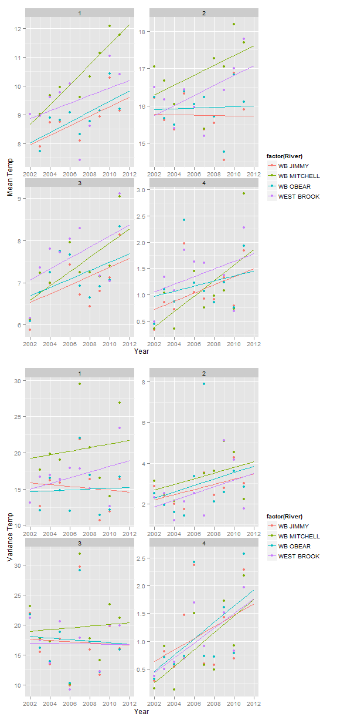

|  |  |  |  |  |  |
| --- | --- | --- | --- | --- | --- |
| Table C. Omnibus F-tests of the change in mean temperature over the study period in each season. | | | | | |
| **Season** | **Effect** | **Num DF** | **Den DF** | **F Value** | **Pr > F** |
| Spring | *Year* | 1 | 26 | 22.79 | <.0001 |
| River | 3 | 26 | 0.95 | 0.4322 |
| River x Year | 3 | 26 | 1.8 | 0.1715 |
| Summer | Year | 1 | 28 | 2.85 | 0.1026 |
| River | 3 | 28 | 0.26 | 0.8524 |
| River x Year | 3 | 28 | 0.9 | 0.455 |
| Fall | *Year* | 1 | 30 | 12.16 | 0.0015 |
| River | 3 | 30 | 0.31 | 0.8164 |
| River x Year | 3 | 30 | 0.22 | 0.8834 |
| Winter | *Year* | 1 | 30 | 7.33 | 0.0111 |
| River | 3 | 30 | 0.66 | 0.5842 |
| River x Year | 3 | 30 | 0.36 | 0.782 |

|  |  |  |  |  |  |
| --- | --- | --- | --- | --- | --- |
| Table D. Omnibus F-tests of the change in variance in flow over the study period in each season. | | | | | |
| **Season** | **Effect** | **Num DF** | **Den DF** | **F Value** | **Pr > F** |
| Spring | *Year* | 1 | 33 | 5.18 | 0.0294 |
| *River* | 3 | 33 | 18.54 | <.0001 |
| River x Year | 3 | 33 | 0.19 | 0.901 |
| Summer | *Year* | 1 | 32 | 3 | 0.0929 |
| *River* | 3 | 32 | 2.76 | 0.0581 |
| River x Year | 3 | 32 | 0.03 | 0.9925 |
| Fall | *Year* | 1 | 32 | 0.24 | 0.6293 |
| *River* | 3 | 32 | 6.43 | 0.0016 |
| River x Year | 3 | 32 | 0.01 | 0.9978 |
| Winter | *Year* | 1 | 32 | 1.71 | 0.2003 |
| *River* | 3 | 32 | 11.41 | <.0001 |
| River x Year | 3 | 32 | 0.03 | 0.9938 |
| Variance in flow is natural-log transformed | | | | | |

